# Fletcher

A Low Poly Procedurally Generated Rogue-like Video Game

## 

Tommy Dalton

20088305  
BSc. (H) Applied Computing

31/12/22

Supervisor- Brendan Lyng

## 

## Table of Contents

**Fletcher** **1**

Table of Contents 2

**3. Introduction** **5**

3.1 Project Concept 5

3.2 Feature Set 5

3.3 Genres 5

3.4 Target Audience 5

3.5 Game Flow Summary 5

3.6 Look and Feel 5

3.7 Project Scope 5

3.7.1 Depth 5

3.7.2 Breadth 6

**4. Investigation of Project Idea** **7**

4.1 Literature Review 7

4.1.1 Goal Oriented Action Planning 7

4.1.2 Internal Economies in Games 8

4.1.3 Procedural Generation In Games 9

4.2 Feasibility 10

4.2.1 Market 10

4.2.2 Similar Products 13

4.2.3 Unique Selling Points 17

4.3 Technical Investigation 18

4.3.1 Target Hardware for Deployment 18

4.3.2 Development Hardware and Software 18

4.3.3 Game Engine 18

4.3.4 Scripting Language 18

5. Project Management 19

5.1 Project Methodology 19

5.2 Detailed Project Schedule 19

5.3 Schedule Management 20

5.4 Version Control 21

5.5 Risk Analysis 21

6. Project Design 22

6.1 Gameplay 22

6.1.1 Game Progression 22

6.1.2 Mission Challenge/Structure 22

6.1.3 Objectives 22

6.1.4 Play Flow 22

6.2 Mechanics 23

6.2.1 Physics 23

6.2.2 Movement 23

6.2.2.1 General Movement 23

6.2.2.1 Environmental Movement 23

6.2.3 Objects 23

6.2.3.1 Scrap 23

6.2.4 Actions 24

6.2.4.1 Dodge/Dimensional Drift 24

6.2.4.2 Rock Tether 24

6.2.4.3 Spying 24

6.2.4.4 Trading 24

6.2.4.5 Weapon Swapping 24

6.2.4.5 Weapon Fire 24

6.2.5 Combat 24

6.2.6 Economy 25

6.3 Screen Flow 25

6.3.1 Screen Flow Chart 25

6.3.2 Screen Descriptions 26

6.3.2.1 Title Screen 26

6.3.2.2 Main Menu 26

6.3.3 Options Menu 26

6.3.4 Gameplay 26

6.3.5 End of Play Session 26

6.4 Game Options 27

6.4.1 Audio Settings 27

6.4.2 Visual Aid 27

6.4.3 Control Configuration 27

6.5 Replay and Saving 27

6.6 Story and Narrative 27

6.6.1 Back Story 27

6.6.2 Plot Elements 27

6.7 Game World 28

6.7.1 General Look and Feel of the World 28

6.7.2 Area 1: Icy Incursion 28

6.7.2.1 General Description 28

6.7.2.2 Physical Characteristics 28

6.7.2.3 Levels that use this area 28

6.7.2.4 Connection to other areas 28

6.7.3 Area 2: Rocky Romp 28

6.7.3.1 General Description 28

6.7.3.2 Physical Characteristics 29

6.7.3.3 Levels that use this area 29

6.7.3.4 Connection to other areas 29

6.7.4 Area 3: Metallic Mania 29

6.7.4.1 General Description 29

6.7.4.2 Physical Characteristics 29

6.7.4.3 Levels that use this area 29

6.7.4.4 Connection to other areas 29

6.7.5 Area 4: Lith Ring 29

6.7.5.1 General Description 29

6.7.5.2 Physical Characteristics 29

6.7.5.3 Levels that use this area 29

6.7.5.4 Connection to other areas 29

6.7.6 Area 5: Anomalous Ring 30

6.7.6.1 General Description 30

6.7.6.2 Physical Characteristics 30

6.7.6.3 Levels that use this area 30

6.7.5.4 Connection to other areas 30

6.8 Levels 30

6.8.1 Overview 30

6.8.2 Beat Chart 30

6.9 Interface 31

6.9.1 Visual Systems 31

6.9.1.1 Heads Up Display 31

6.9.1.2 Options Menu 32

6.9.2 Control Scheme 33

6.9.2.1 General Movement 33

6.9.2.2 Rotation 33

6.9.2.3 Fire Weapon 33

6.9.2.4 Dodge 33

6.9.3 Audio 33

6.9.3.1 Music 33

6.9.3.2 Sound Effects 33

6.9.3.2.1 Weapon Sound Effects 33

6.9.3.2.2 Sound Cues 34

6.10 AI 34

6.10.1 Enemy AI 34

6.10.1.1 Swarm Enemies 34

6.10.1.2 Gunboat Enemies 34

6.10.1.3 Scrapper Enemies 34

6.11 Game Art 35

6.11.1 Concept Art 36

**7. References** **38**

Image Sources 39

**8. Dev Log Playlist and Pre-Recorded Demo** **40**

## 

## 3. Introduction

### 3.1 Project Concept

The basis of Fletcher is to design an Isometric roguelike bullet hell utilising science fiction and low poly aesthetics. Each level of Fletcher will be generated using procedural generation for the design and layout of the level. AI present with Fletcher will utilise a planning system for the enemies to allow for planning and smart decision-making.

### 3.2 Feature Set

* Fast Combat
* Smart AI
* Procedural Generation

### 3.3 Genres

* Science Fiction
* Space
* Rogue-like
* Bullet-Hell
* Isometric

### 3.4 Target Audience

In terms of age group the game will be targeted at players of all ages. Mainly targeted at players using a Windows 10 Desktop.

### 3.5 Game Flow Summary

Fletcher starts off very timidly providing the player with a chance to understand the systems and controls to get a grasp of some mechanics. With each level, however, the difficulty will increase with the intent of the player's skills being developed and sharpened from level to level.

### 3.6 Look and Feel

Fletcher draws inspiration from both classic and modern game designs utilising a mixture of old and new techniques. The overall model fidelity of the project will be low poly with an emphasis on strong texturing and lighting.

### 3.7 Project Scope

#### 3.7.1 Depth

* AI utilising Goal Oriented Action Planning for complex behaviours.
  + Responsive Behaviour
  + Flight and Attack formations
  + Patrolling
  + Retreating
* Procedural Generation to generate levels with different layouts to make each run different.
  + Fully generated levels with interactable that are traversable by the player.
  + Place enemies within the level.
* Focus on Internal Economy
  + Design and mechanical decisions to force the player into making strategic decisions.
  + Resource Management that encourages engagement.

#### 3.7.2 Breadth

* 3 Enemy Types
  + Swarm Fighters: Often attacking the player in packs of 3 with squad-like behaviour becoming less brave/aggressive as their pack diminishes and also joining other packs if their original one is destroyed.
  + Gun Boats: Keep a large distance from themselves and the player firing large volleys of homing projectiles. Dangerous at a distance.
  + Scrapper: Cowardly enemy that will attempt to steal the player's currency, any currency dropped by enemies into the world space will be collected by the scrapper. Incentivising the player to prioritise dealing with this enemy.
* 5 Levels
  + Randomly generated with variations based on the level number.
* 4 Weapon Types
  + Auto Cannon: Rapid fire weapon ideal for dealing with single targets.
  + Tesla Launcher: Fire slow moving high damage orb which once it hits it chains to multiple targets dealing damage, featuring a cooldown between uses.
  + Rail Gun: High-Velocity Projectile that can pierce through all targets damaging all it passes through. Weapon Features high recoil which can push the player in the opposite direction they are facing.
  + Helix Cannon: Rapid Fire Split Stream weapon with each stream firing in sin wave patterns.
* Mechanics
  + Ship to Ship Combat
  + Exploration
  + Arena Combat

## 

## 

## 4. Investigation of Project Idea

### 4.1 Literature Review

#### 4.1.1 Goal Oriented Action Planning

A crucial component of the single-player gaming experience is the game's artificial intelligence (AI) and its behaviour. AI behaviors can be a defining factor of a player's continued interest in the game. The AI should not mindlessly just walk towards the player ignoring its surroundings. Ideally the AI will have a goal and then create a plan to achieve said goal by studying its environment and world state. This is what the *Goal Oriented Action Planning*(GOAP) aims to achieve. The most notable implementation of the GOAP system was in *F.E.A.R (Monolith Productions, 2006)*.

The planning system itself is based upon the Stanford Research Institute Problem Solver (STRIPS) planning system. The STRIPS planning revolves around selecting a goal followed by planning out actions to attempt to change the world state to achieve said goal. Actions in this system may only be carried out if certain conditions are met which then can result in a sub goal being created to be able to complete an action to achieve the overall goal. One of the major differences between STRIPS and GOAP is the application of costs to actions based on the world state (J.Orkin, 2006).

GOAP applies costs to certain actions in order for certain actions to be favoured over others based on the world state. Although a certain action may achieve the goal the precondition for that action may not be true so the AI can fall back onto other actions. GOAP also keeps track of a set amount of world condition variables which help to create the plan. Once a plan has been formulated a copy of the world state is made and the plan is executed upon it to ensure the plan is able to achieve the Goal it has set out, this helps to eliminate the chances of the AI breaking (Tommy Thompson, 2020).

The first Application of the GOAP system was used in F.E.A.R 2006 (Monolith, 2006), but is still used today in a title such as Middle Earth Shadow of Mordor used almost 1:1 to the way it is laid out above and applied to the enemy types.

Within Fletcher GOAP will be used to create seemingly Intelligent A.I based on the world state and the AI state. The main aim is for enemy ships to be able to select their behaviour based on the world around them and create goals as a result. For example if an enemy is low on health they will stay a distance away from the player and attack from a distance. Or if the enemy hasn't seen the player yet they will patrol the environment in search of the player.

#### 4.1.2 Internal Economies in Games

An *Internal Economy* is where resources are gained, drained and exchanged in ways that can be measured. These resources can have direct and indirect impact on the game varying in size depending on the resource. Internal Economies can force players into thinking strategically about their playstyle and resource management (Beat Suter et al). The real world Economy can often affect a business or individual's choices based on their wealth and will often make decisions that would be economically viable.

According to Serpa (2020), internal economies consist of four essential pillars.

* Sources: where a resource is created by nothing at a set production rate.
* Drains: Where a certain action or event removes a resource permanently.
* Converter: Where a resource is transformed into another type of resource at a fixed exchange rate.
* Traders: Where a resource is swapped out for another, neither resource is destroyed it merely changes ownership.

Internal Economies are also the Player's management of a resource and can take many forms, Internal Economy related to games is not limited to currency systems like the ones commonly present in Role-Playing Games such as Skyrim where the player character can exchange coins for items and items for coins with shops and vendors. “In games, things like health, experience, and skill can be part of the economy just as easily as money, goods, and services.” (Ernest and Dormans,2012, p. 59) Core aspects of gameplay such as Health Points are counted as part of the Internal Economy.

For example in the game *Enter the Gungeon(Dodge Roll,2018)* The player with low health points can buy more Health Points for money or perhaps buy a more powerful weapon:

* Buying more health, the player will have the ability to play more aggressively as they can afford to be hit.
* The player that buys the weapon will have increased risk/reward due to them playing on the edge of death.

Forcing the player to think about the game as a whole in both a long term and short term sense based on the risk vs reward of their choices.

When there are many aspects of the internal economy it can broaden the “Probability Space” meaning that there is more chance for variation in the game itself increasing the replay value of the game (Beat Suter et al,2019). This in turn means players will get more of a personal experience out of the game based on their choices alone. To further increase the Probability Space of a game is to design your levels around different play styles allowing players to use different strategies to beat them. However each play style should be viable in the economy as the probability space should be kept open to encourage replay. If certain playstyles have a distinct advantage players will flock to it over others thus reducing Probability Space (Ernest and Dormans,2012).

In this Game Internal Economy will play a key role in its game loop revolving around the player's management of their currency, health, ammunition and weapons. Like what was mentioned above, tight management of these key resources will govern the player's decisions in the game, actively weighing their actions against short term and long term gains and or loss. The Player can use their acquired currency to repair any damages to their ship at the trading post or to upgrade or swap out their weapons leaving the choice of repair versus higher attack power. Currency is gained by successfully killing enemy ships. To increase Probability Space there will be several ship variants being small, medium and large each with different statistics as well as different weapon types to mix and match on each ship.

#### 4.1.3 Procedural Generation In Games

Procedural Generation is the generation of content by computers through the use of algorithms and Artificial Intelligence. Used extensively in the Games Industry for the generation of content as well as to automate development cycles of games to reduce workload. Used commonly for level generation when implemented correctly can have a huge impact on gameplay and the Probability Space of the game.

Methods of Procedural Generation are often made specifically for a game and not made publicly available however there are several thought processes for the design and implementation of Procedural Generation. Constructive Algorithms are mainly used for placing premade components specific to a game following a loose set of rules, these systems are very efficient in content generation but are hard to control and harder to get a good degree of variation out of as the variation can be affected by the rules applied it as well as the amount of pre-made components available to it (Smith, 2015).

Another area of content generation is Evolutionary Algorithms which at a high level essentially employ survival of the fittest by generating lots of content and evaluating the content and picking the best candidates to be merged and rating the outputs of this merge. The goal of the Evolutionary approach is to optimize the output of the Procedurally Generated content to achieve good quality output. This generation method does require a lot of thought and design as to what is deemed as good content as developers would have to come up with guidelines to determine this (Pontes, Gomes, 2020).

Procedural Generations Impact upon gameplay can differ heavily from game to game. An excellent example and application of Procedural Generation can be seen in the game *Minecraft (Mojang Studios, 2011)* where it used to generate huge sandbox landscapes with sprawling massive landscapes with distinct Biomes full of Non-Player-Characters, structures and more are all placed by the game's algorithm in a world so large that player will never reach the limits by normal means. Each time the player creates a new world in the game it is radically different. This contributes well to the replayability of the game as no two worlds are the same.

Within Fletcher Procedural Generation will be used for the creation of levels and the initial placement of enemies and environmental hazards. The ultimate goal for the use of this is to randomise the game each time it is played to try and create a unique play session each time.

### 4.2 Feasibility

#### 4.2.1 Market

### 

Figure 4.1A

The video game industry has been steadily growing over the past 5 years with a spike during 2020, as seen above the revenue generated in 2022 is estimated to be 208.62 Billion US Dollars as seen in the above graph. With a size of 208.62 Billion Dollars I believe the market is sizable enough but we can look at examples of some games within the genres of Fletcher and look at their revenue and player bases to see what sort of demand and interest there is in this sort of game.

**Enter The Gungeon**

Enter the Gungeon is a Twin Stick Shooter Roguelike developed by Dodge Roll and published by Devolver Digital. It will be worth looking into this game's overall revenue and how active the player base is for it. Since the game's original launch back in April of 2016 it is estimated the game has roughly made $18 million with roughly 7 million of that being revenue from the last two years, 4-6 years later the game is still making sales.

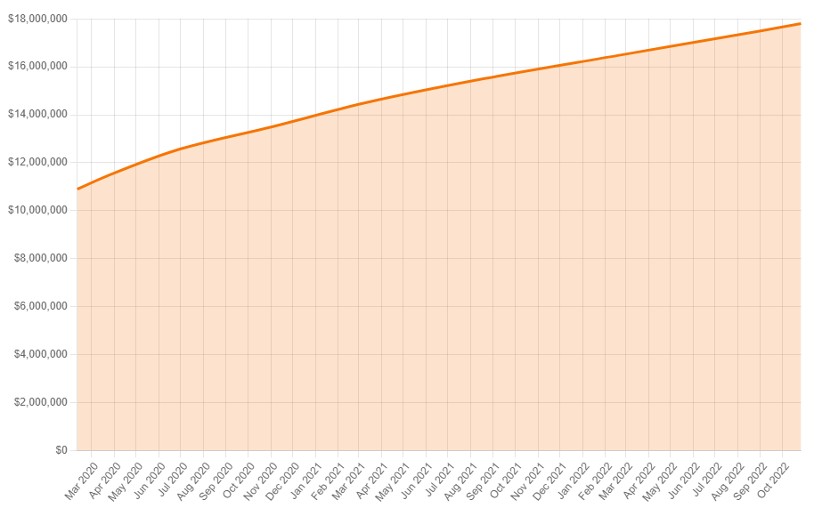

Figure 4.1B Estimated Revenue of Enter the Gungeon on Steam

As can be seen the sales for Enter The Gungeon remain the same but let's take at the player base of the game over time.

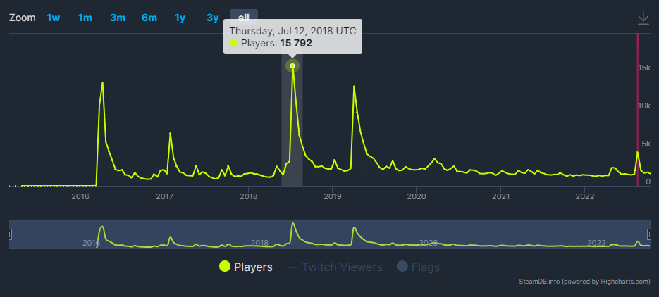

Figure 4.1C Player Trends for Enter the Gungeon from its launch to date.

Throughout the game's six year lifespan the average number of players has remained surprisingly the same in the grand scheme of things with some spikes over the course of its availability. The dates of the spikes is around the time of major content updates for the game which in this game were free. It is a very common trend for games within the roguelike genre to do content updates which regenerates interest in the title bringing in new players to purchase the game and bringing back older players. At the very end of the above graph the player count is 1589 concurrent players. Enter the Gungeon has done very well and has retained a very sizable concurrent player base for a single player roguelike. Now we will look at a more recent popular release within the roguelike genre.

**Vampire Survivors**

Vampire Survivors is another Roguelike that was released in December of 2021 on itch.io and is also in Early Access on Steam, the stats I will be looking at for this game are based on statistics gathered from Steam. So first we will take a look at the estimated revenue.

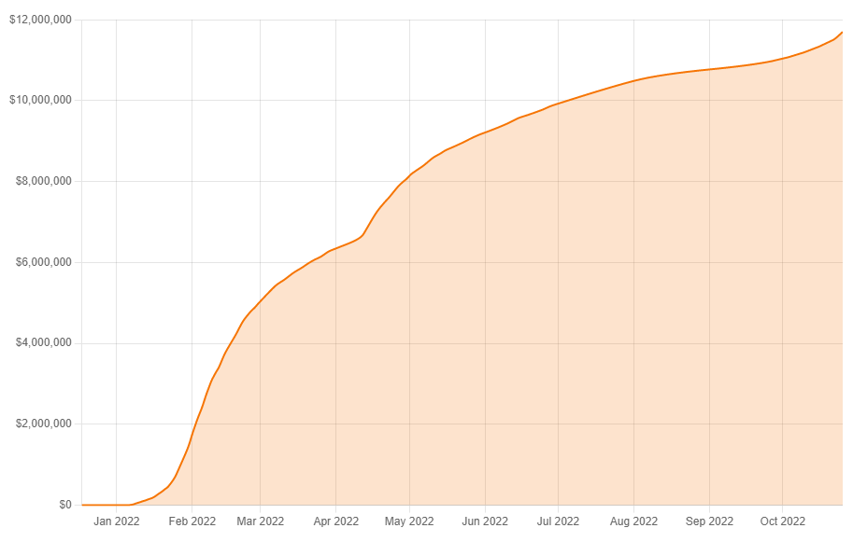

Figure 4.1D Estimated Revenue of Vampire Survivors from Launch to date

As of November 2022 this game is estimated to have generated $12 Million in under a year of release which when compared to Enter the Gungeon is astronomical in comparison however this could possibly be attributed to the games very low price. But regardless this amount of revenue in such a short amount of time is still impressive.

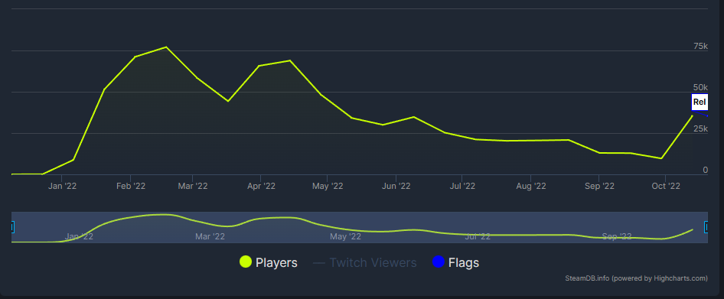

Figure 4.1E Player Count of Vampire Survivors on Steam

As for the concurrent player count it has peaked at over 75 thousand players which is over triple the amount of Enter The Gungeon’s peak concurrent player count, like before this could be attributed to the low price of the game.

### 4.2.2 Similar Products

Enter The Gungeon (Dodge Roll, 2016)

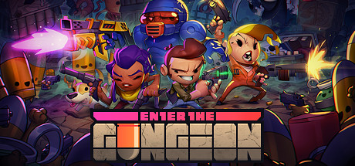

Fig 4.2.2A Enter the Gungeon Promotional Art

Enter the Gungeon is a roguelike bullet hell where the player must travel through 5 layers of the Titular “Gungeon'' which is a firearm themed dungeon containing a plethora of enemy types to challenge the player. The main similarity between this game and Fletcher is its rogue-like structure and procedural generation methods.

**Procedural Generation**

The generation method in Enter The Gungeon generates its levels by placing rooms which connect to one another. These rooms are premade but are chosen and placed randomly and connected up to make a path to the boss fight and several other paths for the player to explore.

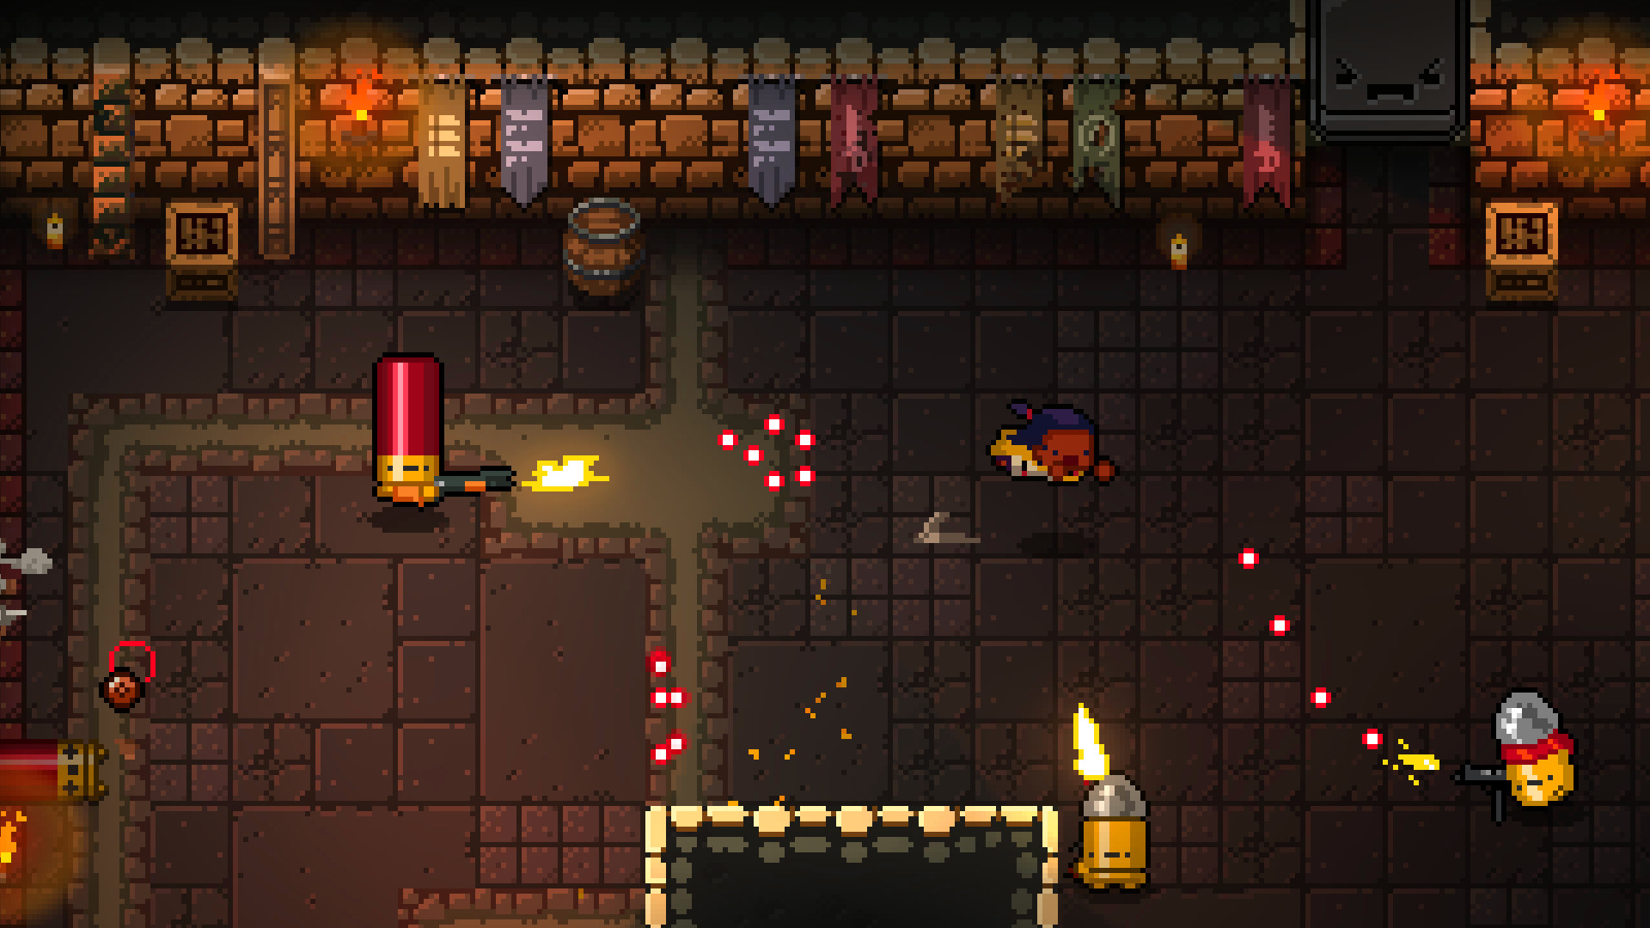

Fig 4.2.2B Enter The Gungeon in game screenshot

**Internal-Economy**

Enter the Gungeon has a very tight grip on its internal economy, this relating to the player's management of their main resources, those being the player's health, ammo, and currency. Being a bullet hell and a rogue like one of the quick discoveries made by the player will be how rare healing items are forcing the player to play very cautiously. Outside of the starting weapon and a few exceptions ammo is finite and the player will often find themselves making the decision of whether or not to use their power weapon to clear a room of enemies.

**The Ascent**

The Ascent is an isometric action shooter featuring RPG elements.

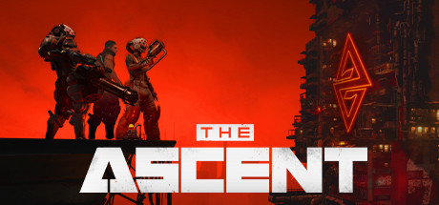

Fig 4.2.2C Promotional Art for The Ascent

Relating to Fletcher is mainly the view of the player and combat style. However the main difference in combat between this game and Fletcher is the dependence on cover. The Ascent utilises cover heavily while Fletcher will focus on the player moving and navigating the stage to avoid taking damage.

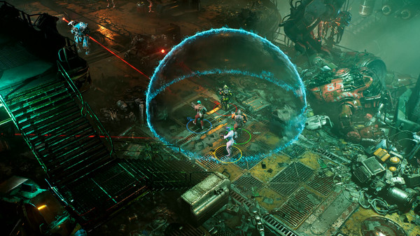

Fig 4.2.2D In game screenshot of The Ascent

**Nuclear Throne (Vlambeer, 2015)**

Nuclear Throne is a post-apocalyptic bullet hell roguelike where the player can play as one of 12 characters.

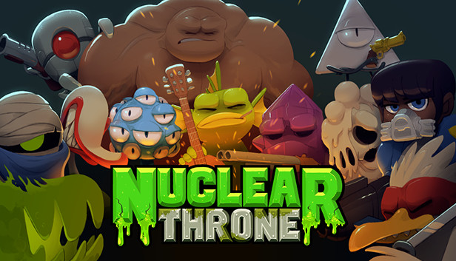

Fig 4.2.2E Nuclear Throne Promotional Art

**RogueLike**

Nuclear Throne is a Roguelike game in that once a player has lost all progress is lost and the player must restart from the very start. Outside of challenges and achievements no other in game progress is retained from a previous play session, the only thing the player retains and gains is their knowledge and understanding of the game's systems.

**Procedural Generation**

A major aspect of the RogueLike genre is that certain aspects of the game are randomised to ensure the player's constant engagement, by making each play session different for them. Each level in Nuclear Throne is procedurally generated with almost a different layout everytime. The world space, enemies, ammo and interactables are placed randomly. Tile sets, enemy types and weapons differ depending on how far into the game the player is. Most levels with a few exceptions are fully generated by procedural means.

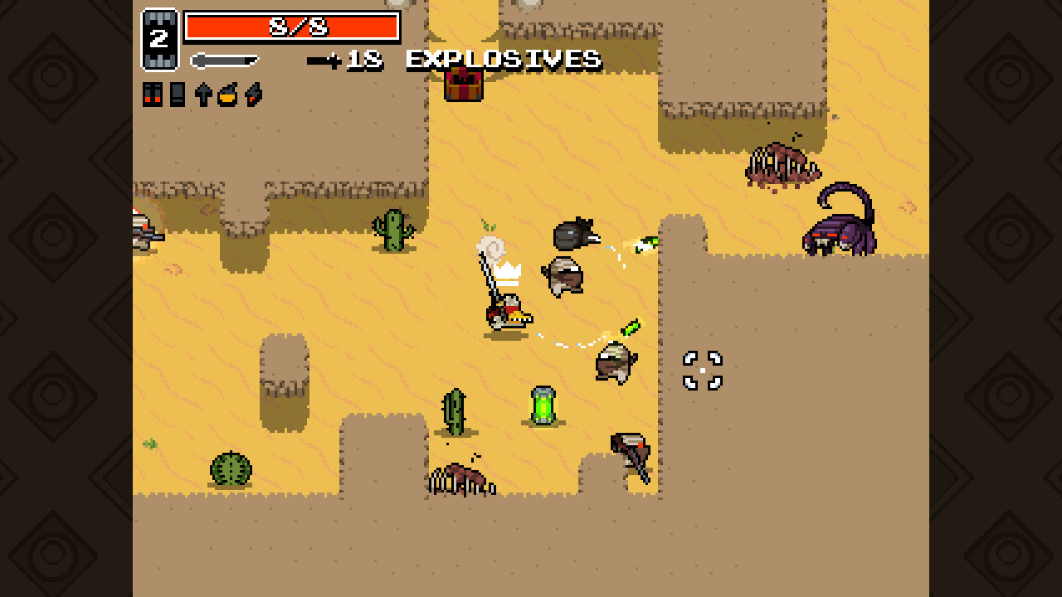

Fig 4.2.2F In game screenshot of Nuclear Throne

### 4.2.3 Unique Selling Points

* Goal Oriented Action Planning being used in a roguelike game.
* Tight control of the economy for increased engagement.

## 

### 4.3 Technical Investigation

#### 4.3.1 Target Hardware for Deployment

* Personal Computer
  + CPU:Quad Core 2.4gHz
  + Memory: 4-8GB 2133mhz
  + Storage: 10GB
  + GPU: GTX 970 or Equivalent
  + Operating System: Windows 10 or Higher

#### 4.3.2 Development Hardware and Software

* CPU: Ryzen 5 2600x
* RAM: 32gb 2133mhz
* GPU: RX570 8gb
* Blender: For creating 3d Assets
* Microsoft Visual Studio

#### 4.3.3 Game Engine

The game engine selected for the creation of Fletcher is Unity. Unity is a cross platform game development engine. Using a pre-built engine will cut down on development time as things such as 3d Graphics and physics are already set up and available to the user.

#### 4.3.4 Scripting Language

The scripting language that will be used for this project is c# as it is the main language of choice for scripting in the Unity Game Engine.

## **5. Project Management**

### **5.1 Project Methodology**

The Project Methodology that will be employed for the creation of Fletcher will be the Scrum methodology.The Scrum project management methodology is an incremental system for development over time periods ranging between two and four weeks known as sprints. The system of bi-weekly sprints, a project backlog and sprint backlog will allow for the easy management of existing, in progress and new tasks relating to the development of Fletcher. Scrum is used widely across several industries. Scrum is also used within the games industry to coordinate large teams to complete large tasks and projects on time through the high levels of coordination and communication offered by the scrum methodology (Keith,C 2010). The scrum system was originally proposed as a team oriented management system in the original 1986 article (Takeuchia and Nonaka, 1986) but some slight alterations will need to be made to suit the lack of a team working on Fletcher.

| **Scrum Component** | **Using** | **Reason** |
| --- | --- | --- |
| Daily Standup | No | One Person Team |
| Sprint Planning | Yes | It is important to reserve time to review the current interests of development and identify the path forward by selecting tasks which align with what is needed |
| Sprint Review | Yes | Look back over work done and general approach during previous sprint and come up with ideas or procedures to avoid shortcoming and or to to generally improve performance |
| Backlog Refinement | Yes | Looking at what's present in the backlog and adding notes is important for developer work later |
| Sprint Retrospective | No |  |

### **5.2 Detailed Project Schedule**

| **Sprint #** | **End Date** | **Duration**  **(wks)** | **Deliverables** | **Progress** | **Devlog link** |
| --- | --- | --- | --- | --- | --- |
| 1 |  | 2 | Doc: Proposal complete  Trello Board Setup | Complete | n/a |
| 2 | 13/10/22 | 2 | Doc: Section 4 Literature Review  Basic Player Movement in Unity’s new Input system | Complete | n/a |
| 3 | 27/10/22 | 2 | Doc: Section 3.7 Project Scope  Doc: Section 4 feedback addressed  Basic Machine Gun weapon added with hit detection  Devlog  Updated Trello Board | Complete | [[LINK]](https://youtu.be/UhzRAyQRsE8) |
| 4 | 10/11/22 | 2 | Citations Corrected  Doc: Section 5 Project Management  Devlog  New Weapon types  Player model  Player Options | Complete | [[LINK]](https://youtu.be/vzGN6vwDcAI) |
| 5 | 24/11/22 | 2 | Iterate Prototype (Proc Gen)  Doc: Complete Section 6  Update Trello  Create Devlog | Complete | [[LINK]](https://youtu.be/nAe3p2MUKCs) |
| 6 | 8/12/22 | 2 | Iterate Prototype (Proc Gen)  Doc: Complete Documentation  Update Trello  Create Final Devlog for Semester | Complete | [[LINK]](https://youtu.be/Ch0jck9ls2k) |

### **5.3 Schedule Management**

The Project management tool that will be used for Fletcher is Trello. Trello is a kanban style, list making application. The selection of trello was due to the fact that trello is very simple to use and can be organised with ease.

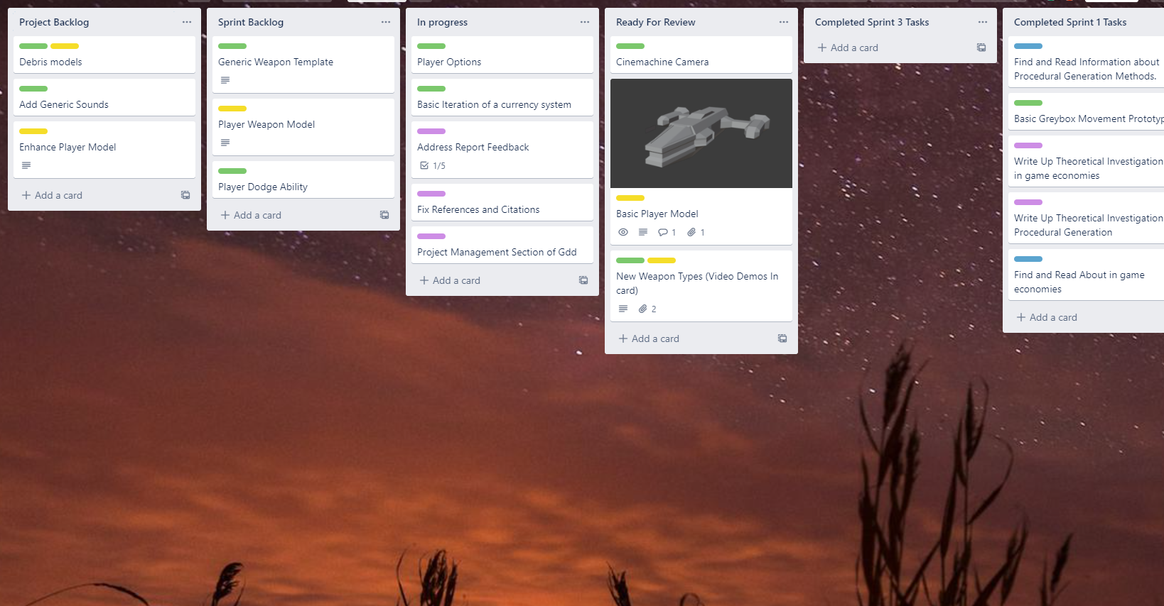

Setup following the scrum ideology the Trello Board for Fletcher consists of the following.

**Project Backlog**

Overall cards for the project as a whole, any new cards that are created remain in the backlog until identified as being a part of the next Sprint during sprint planning.

**Sprint Backlog**

Cards present in the sprint backlog are cards that will be worked on in the current active sprint.

**In Progress**

Cards that are actively being worked on will be placed in this category.

**Ready for Review**

Any work that is completed and is ready for checking/validation that will be placed here.

**Sprint Completion Columns**

Any work that is completed is placed in their respective sprint completion column.

Having the above layout on Trello allows for easy management of project aspects

### **5.4 Version Control**

The main version control for Fletcher will be through Unity’s Plastic SCM which allows for branching development and cloud storage of the project. This will allow for access to the project at any system with unity installed and an internet connection. Plastic SCM also has github support which will allow for the project to be stored on both platforms adding an extra layer of security for data loss.

### **5.5 Risk Analysis**

| **Risk Description** | **Risk Probability** | **Risk Impact** | **Risk Mitigation Strategy** |
| --- | --- | --- | --- |
| Under estimation of project difficulty | High | High |  |
| Contracting Covid or Illness | Low | Low | Avoiding Sickness, following Government Guidelines in relation to Covid 19 |
| Inability to meet deadlines | Med | Med |  |
| Lose of Report/Documentation | Low | High | Documentation stored on Google Drive with regular Copies stored on several devices locally. |
| Lose of Unity Project/Workspace | Med | High | The use of Plastic SCM for cloud storage of the project and local copies kept on local devices. |

**5.6 Test Plan**

|  | Test Plan |
| --- | --- |
| When? | At the end of every sprint. |
| Who? | Colleagues will test different builds of the game. |
| Where? | Over the internet by sending the tester a build of the game. The lack of presence of the developer will hopefully help to alleviate politeness in favour of critical analysis. |
| What? | Feedback on specific concerns discovered during development as well as any personal grievances the playtester has with the build. |
| How? | The developer will not be present and will provide the playtester with an executable for the game followed by a brief questionnaire with general questions and a section for specific feedback for any grievances they might have or any discoveries etc. |

## **6. Project Design**

### 6.1 Gameplay

#### 6.1.1 Game Progression

Starting out, the player will drop into a random point within the first level. It is up to the player to fully explore the level, clearing out three to five large groupings of enemies in order to progress to the boss. The player will be able to use Scrap (the main currency) to upgrade and repair themselves at a trading post located somewhere in the level. This process is repeated again for the following 4 levels.

#### 6.1.2 Mission Challenge/Structure

Each level will consist of the player making a decision, is it within the player's interest to explore the surrounding level fully or search for the boss in order to progress as quickly as possible. Present in each level will be roaming packs of enemies and areas that will lock the player into combat within the confine of the area.

#### 6.1.3 Objectives

The main objective for the player is to fight and explore their way through five randomly generated levels. Going from area to area in search of the exit.

#### 6.1.4 Play Flow

The flow of the game will be affected mainly by how the player is managing themselves, their resources and the world around them. Following some of the ideas mentioned above in section 4.1 the Internal Economy of the game will have a large impact upon the players decisions often encouraging the player to either play more reserved or even to play bolder at a high risk high reward playstyle. Another aspect will be how far the player has progressed as the levels get increasingly difficult as such the player's engagement should increase with the difficulty. A mixture of the difficulty increase and the players resource management should provide enough challenge and engagement.

### 6.2 Mechanics

#### 6.2.1 Physics

Within Fletcher physics will be used for the propulsion of projectiles and the players. The game will mostly take place on the x and y planes so all physics calculations will mostly be two dimensional.

### 6.2.2 Movement

Movement will depend on what the player is using as there will be two options available to the player, those being the mouse and keyboard and Xbox Controller.

#### 6.2.2.1 General Movement

As mentioned before movement will mainly take place on the x and z planes. On the controller movement and rotation will be controlled by the left and right analog stick respectively. On the controller the direction you move is based on the direction the stick is moved while on keyboard movement will be based on the input for example pressing the W key will move the player forward and S for down.

The overall speed of the player will increase rapidly up to the max value but no more. By default the player will move at a set speed for consistent control.

#### 6.2.2.1 Environmental Movement

Certain interaction with the environment will cause the player and certain entities to be moved. For example an explosion will cause knockback pushing the player and certain entities back. Gravity wells will sling the player and enemies across a large space quickly.

### 6.2.3 Objects

#### 6.2.3.1 Scrap

When an enemy dies scrap will be spawned. Scrap acts as the main source of currency within Fletcher.

### 6.2.4 Actions

#### 6.2.4.1 Dodge/Dimensional Drift

The Dodge causes the player to disappear and reappear a moment later in a location forward from the way the player was last travelling. During the duration of the dodge the player is not visible and cannot be hit. A short cooldown will be put into place to prevent near invulnerability from overuse.

#### 6.2.4.2 Rock Tether

Taking nearby rocks to form a defensive barrier in front of the player at the price of blocking the player's own attacks.

#### 6.2.4.3 Spying

Activating enemy comms pylons will allow the player to get a sense of what the enemy is thinking and allow them to plan accordingly. If the player has been seen recently the enemies will be on high alert, if the player hasn't been seen the enemies will not be searching for the player.

#### 6.2.4.4 Trading

Located within the belt are several structures which act as a sort of checkpoint for the player as it is an area where the player will not be followed by enemies, here the player can exchange the scrap they have earned through combat for repairs and possible upgrades.

#### 6.2.4.5 Weapon Swapping

This will allow the player to swap the active weapon between two that are equipped aboard the ship.

#### 6.2.4.5 Weapon Fire

Firing the active weapon will spawn a projectile which will move forward from the direction that the player was facing when the weapon was fired. The rate of fire is dependent on the weapon in use, some weapons may only spawn a projectiles on tap while other will fire as long as the button for firing the weapon is held down

### 6.2.5 Combat

Occurring mainly once the player has been spotted or once the player has entered a combat area both the player and the enemy AI will fire projectiles back and forth. If a projectile from the player collides with an enemy the enemy will take damage equivalent to whatever the value for it is on the projectile. The same will occur for the player if the player has been hit by enemies projectile. The player can avoid being hit using their dodge or tether ability.

### 6.2.6 Economy

Revolving mainly around the currency item Scrap which is gained from defeating enemies the economy will serve the purpose as acting as either the player's lifeline for getting necessary repairs or as a means of gaining upgrades. Discussed back in section 4.1.2 the economy of the game will play a pivotal role in the project guiding decisions being made by the player. The value of scrap will remain the same but prices for activities such as repair will go up in value from level to level.

### 6.3 Screen Flow

#### 6.3.1 Screen Flow Chart

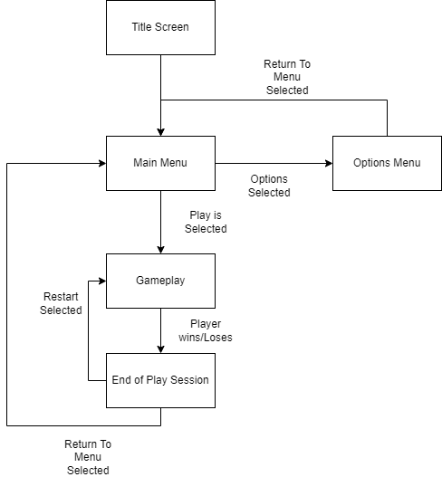

#### 6.3.2 Screen Descriptions

#### 6.3.2.1 Title Screen

The title screen will be the first screen the player sees upon launching the game. Consisting mainly of the game's title Fletcher and a prompt for the player to press any button to load into the main menu.

#### 6.3.2.2 Main Menu

The main menu acts as the main functional screen allowing the player to choose between two options.

**Play**

Choosing play will load the player into level 1 allowing them to actually play the game from this point onwards.

**Options**

Will load the player into the options menu.

#### 6.3.3 Options Menu

Accessed by selecting options from the Main Menu screen here the player will have access to a series of Ui elements which will allow them to interactively configure their preferences for options.

#### 6.3.4 Gameplay

Accessed from the main menu when the player selects play it is in this screen where the game is played and fully interacted with by the player.

#### 6.3.5 End of Play Session

Once the player loses or even wins they will see this screen, This screen will display to the player their current stats,score, general performance etc. From this screen the player will be given two options.

**Return To Main Menu**

This will return the player to the main menu of the game.

**Restart**

Restart the game from level 1 which will loop back into the gameplay screen starting the play session over again.

### 6.4 Game Options

#### 6.4.1 Audio Settings

* Master Audio: The Universal audio value which will dictate how loud the entire game is.
* Sound Effect Audio: Allows for configuration of how loud sound effects are in the game.

#### 6.4.2 Visual Aid

* Configuration to alter the materials and textures applied to game critical entities for quick identification. For example marking enemies as red players as blue or green etc.

#### 6.4.3 Control Configuration

* Input Rebinding
  + Changing the actions that are performed by certain inputs through the game options.

### 6.5 Replay and Saving

Fletcher will be a roguelike game meaning it will offer no saving of the player's progression, at most it will offer the saving of the player's score. Replayability will be a cornerstone of Fletcher as the goal is for each run to be different. This will be achieved mainly through procedural generation.

### 6.6 Story and Narrative

#### 6.6.1 Back Story

In the distant future Humanity has decided it wishes to reach to the stars, to see all the wonders and horrors the universe has to offer. Humanity has developed faster than light travel but has not yet developed faster than light communication so all exploration data has to be manually returned to earth. The universe is quite a large place so humanity leaves the tasks to autonomous drones known as Fletcher equipped with a Faster Than Light Engine, Sophisticated AI and compatibility with several weapon systems in fear of not being alone in this universe. Suffering from a malfunction the Fletcher drone finds itself stuck in the confines of a dense asteroid belt orbiting a gas giant.

#### 6.6.2 Plot Elements

**Exposition**

The player will be given vague objectives to find a way to escape the ring.

**Rising Action**

As the player explores the ring they will encounter enemies that they will have to fight off. The drone discovers rifts which allows them to travel further within the ring.

**Climax**

Each time the drone uses a rift not only does the drone get propelled to a different location within the ring it is also seemingly pushed forward in time as the gas giant has shifted color and there are significantly less stars visible.

**Falling Action**

As the drone fights its way through the different rings jumping forward in time the drone find itself significantly forward in time as the heat death of the universe has begun.

**Resolution**

After jumping through one final rift the drone is all that remains in the empty shell of the universe. All the light has gone and the drone sits dormant awaiting the supposed birth of a new universe at the end of the current one.

### 6.7 Game World

#### 6.7.1 General Look and Feel of the World

Fletcher takes place in an asteroid belt orbiting a large gas giant in an allegedly unexplored part of space. Asteroid Belts consist mainly of large asteroids, small rocks and dust that form a dense fog. Strangely, present throughout the ring is metallic debris and autonomous constructs unknown to that of the main character. Also present throughout the ring are several scientific anomalies of varying impact and colour.

#### 6.7.2 Area 1: Icy Incursion

##### 6.7.2.1 General Description

Icy section of the planetary rings. Consisting of blue/white icy rocks containing light amounts of debris.

##### 6.7.2.2 Physical Characteristics

A thick white fog will be present due to the icy rocks and cold temperatures within this section of the ring. Gaps within the icy ring will be available for the player to safely traverse.

##### 6.7.2.3 Levels that use this area

Level 1 will use this area.

##### 6.7.2.4 Connection to other areas

Beating this level will put the player into level 2 which uses area 2.

#### 6.7.3 Area 2: Rocky Romp

##### 6.7.3.1 General Description

Rocky section of the planetary rings. Consisting of asteroids consisting mainly of stone. The asteroids in this section of the ring are way more unstable and are likely to crack and splinter apart hurtling into other asteroids and other unfortunate parties. The Gas Giant the rings are orbiting has changed colour.

##### 6.7.3.2 Physical Characteristics

A similar fog to the first area will be present in this area with the rocks being brown in colour with a different and more jagged look to that of the ones in the icy ring. Some rocks have been eroded by some means.

##### 6.7.3.3 Levels that use this area

Level 2 will use this area

##### 6.7.3.4 Connection to other areas

Beating this level will put the player into level 3 which uses area 3

#### 6.7.4 Area 3: Metallic Mania

##### 6.7.4.1 General Description

Asteroids present in this section of the ring are of a high metallic content with a similar fog to the other areas present.

##### 6.7.4.2 Physical Characteristics

A similar fog to the first area will be present in this area with the asteroids reflecting more light and colouring from silver colours to black.

##### 6.7.4.3 Levels that use this area

Level 3 will use this area

##### 6.7.4.4 Connection to other areas

Beating this level will put the player into level 4 which uses area 4

#### 6.7.5 Area 4: Lith Ring

##### 6.7.5.1 General Description

Asteroids present in this section of the ring are seemingly porous with signs of life. The Gas giant has once again shifted colour and less stars are visible.

##### 6.7.5.2 Physical Characteristics

A similar fog to the first area will be present in this area with porous asteroids and smaller chunks of asteroid debris being present.

##### 6.7.5.3 Levels that use this area

Level 4 will use this area

##### 6.7.5.4 Connection to other areas

Beating this level will put the player into level 5 which uses area 5.

#### 6.7.6 Area 5: Anomalous Ring

##### 6.7.6.1 General Description

Asteroids present in this section of the ring are now hollow and cracked with a blue/purple colouring..

##### 6.7.6.2 Physical Characteristics

A dense fog is present with lightning storms visible.

##### 6.7.6.3 Levels that use this area

Level 5 will use this area

##### 6.7.5.4 Connection to other areas

Beating this level will finish the game.

### 6.8 Levels

#### 6.8.1 Overview

5 levels are planned for fletcher. Each level will have its own style and hazards to provide challenge to the player

#### 6.8.2 Beat Chart

Beat charts are a simple table used to keep track of the feature, mechanics and aspects of each level of a game.

|  | Level 1 | Level 2 | Level 3 | Level 4 | Level 5 |
| --- | --- | --- | --- | --- | --- |
| Location | Ice Ring | Rocky Ring | Metallic Ring | Lith Nest | End of Things |
| Story Beat | Arrival in the rings. | Time Jump aftermath, arrived in rocky ring now | Time Jump aftermath, arrived in metallic now | Time Jump aftermath, arrived in Lith Nest now | Time Jump aftermath, arrived near the end |
| Progression |  |  |  |  |  |
| Est. Playtime | 5 - 15 mins | 5-15 mins | 10-20 mins | 10-20 mins | 10 - 20 mins |
| Colour Map | White and Blue (Asteroids) | Brown and Orange Asteroids | Shiny Metallic shade asteroids | Dark Red Asteroids, red mist | Purple asteroids |
| Enemies | Drones (swarm), | Drones (swarm), Piercers(Gunboats) | Drones (swarm), Piercers(Gunboats) | Drones (swarm), Piercers(Gunboats) | Drones (swarm), Piercers(Gunboats) |
| Mechanics | Combat, Exploration | Combat, Exploration | Combat, Exploration | Combat, Exploration | Combat Exploration |
| Hazards | Fragile Asteroids, freezing mists | Fragile Asteroids, corrosive rocks. | Fragile Asteroids, Magnetic Fields, small amounts of anomalies |  | Large amounts of anomalies. |
| Abilities | Attack,Dodge, Machine Gun |  |  |  |  |
| Economy | Scrap dropped by enemies, Repair Station | Scrap dropped by enemies, Repair Station | Scrap dropped by enemies, Repair Station | Scrap dropped by enemies, Repair Station | Scrap dropped by enemies, Repair Station |

### 

### 6.9 Interface

#### 6.9.1 Visual Systems

#### 6.9.1.1 Heads Up Display

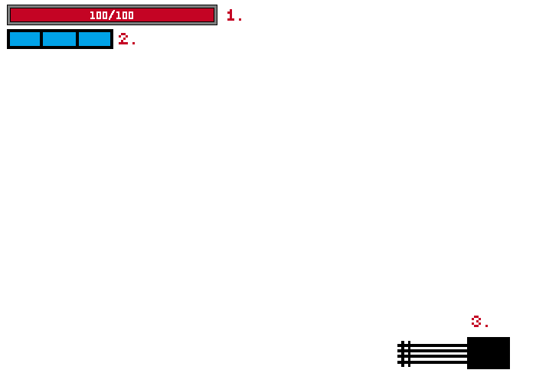

1. Player Health
2. Player Stamina for Dodging
3. Players Currently Equipped weapon

##### 6.9.1.2 Options Menu

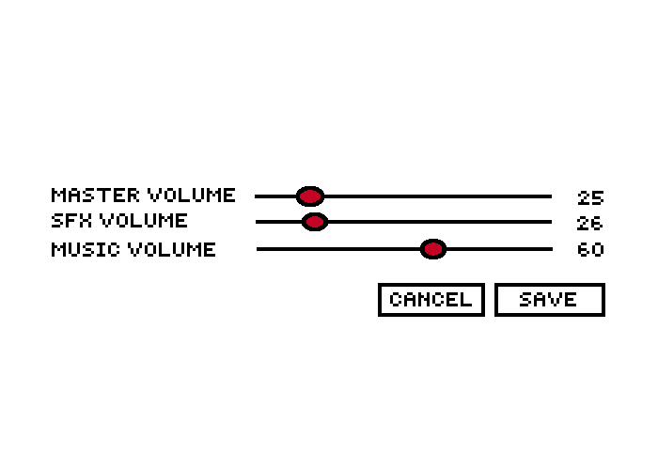

6.9.1.3 Main Menu

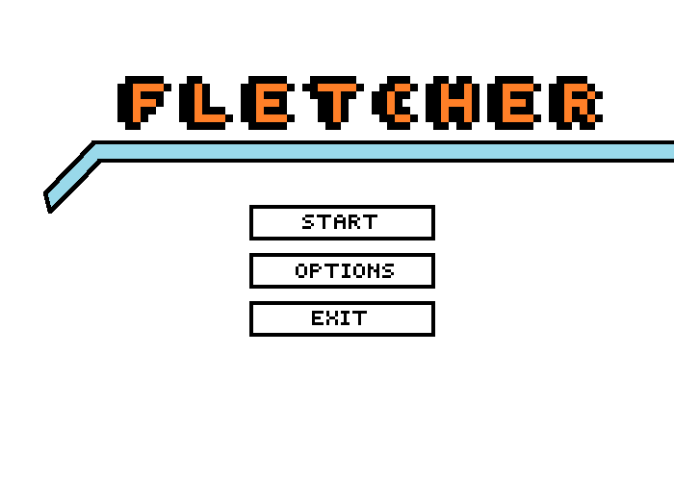

6.9.1.4 Camera

The camera in Fletcher will be isometric being placed above the player facing down towards the player at an angle.

#### 6.9.2 Control Scheme

Fletcher will have support for two kinds of control input. Those being controllers and mouse and keyboard.

##### 6.9.2.1 General Movement

On controller movement in the worldspace is controlled by input from the left analog stick.

On mouse and keyboard movement is controlled by the W,A,S and D keys each representing their own respective direction.

##### 6.9.2.2 Rotation

Rotation i.e the direction the player is facing differs slightly on each input form. On controllers the direction the player is facing is based on which direction the right stick is pushed.

On mouse and keyboard the player will face towards the player's mouse.

##### 6.9.2.3 Fire Weapon

On controller pressing the right trigger will fire the currently equipped weapon.

On mouse and keyboard pressing m1/left click on the mouse will fire the currently equipped weapon.

##### 6.9.2.4 Dodge

On controller pressing the B button will make the player perform the dodge ability.

On mouse and keyboard pressing right click will make the player perform the dodge ability.

#### 6.9.3 Audio

##### 6.9.3.1 Music

The music for Fletcher will draw mainly from its sci-fi aspects in terms of its style. Depending on what the player is currently doing the music will switch. During general exploration and light combat i.e small enemy groups, exploration music will play. When a large swarm of enemies are present more intense combat music will play.

##### 6.9.3.2 Sound Effects

###### 6.9.3.2.1 Weapon Sound Effects

These will be sound effects that will only be used when the player is actively using their weapons. Range from gunshot effects to sci-fi laser beam sound effects.

###### 6.9.3.2.2 Sound Cues

Sound cues will be used to alert the player to the starting of certain encounters/events such as being ambushed or the start of a combat area.

### 6.10 AI

The AI in Fletcher will utilise the Goal Oriented Action Planning system see section 4.1. For a GOAP system we need goals and action that can be used to achieve these goals. The GOAP system keeps track of World state which will influence what actions the enemy can use to achieve their set out goal. Each AI type will have access to a certain set of actions based on what type they are. Once a goal is set the AI will then execute the plan on a copy of the world state before actually attempting to use the plan if the plan is successfully carried out on the copy of the world state it will then be used in game. This reduces the chance of the AI failing.

#### 6.10.1 Enemy AI

##### 6.10.1.1 Swarm Enemies

Swarm enemies prioritise being aggressive towards the player and attacking in tandem with two other swarm fighters. As the player defeats members of the swarm their behaviour becomes less aggressive favouring more defensive/cowardly behaviour as their numbers have diminished, prioritising finding and joining a new swarm over attacking the player. Using GOAP implementing this general prioritisation of is feasible through the use of world state information and adjusting costs of actions based on the world state information.

##### 6.10.1.2 Gunboat Enemies

Gunboat enemies favour keeping their distance from the player with the main effector to their choice of actions based on how close the player is to them. Attacking the player from distance is their ideal course of action to deal with the player followed by retreating once the player is too close.

##### 6.10.1.3 Scrapper Enemies

These enemies will avoid the player and prioritise collecting the scrap dropped by other enemies.

### 

### 6.11 Game Art

The main inspirations for the art direction for this project originate in Science fiction and low poly styled video games of the past and the present. Some Examples would be the following.

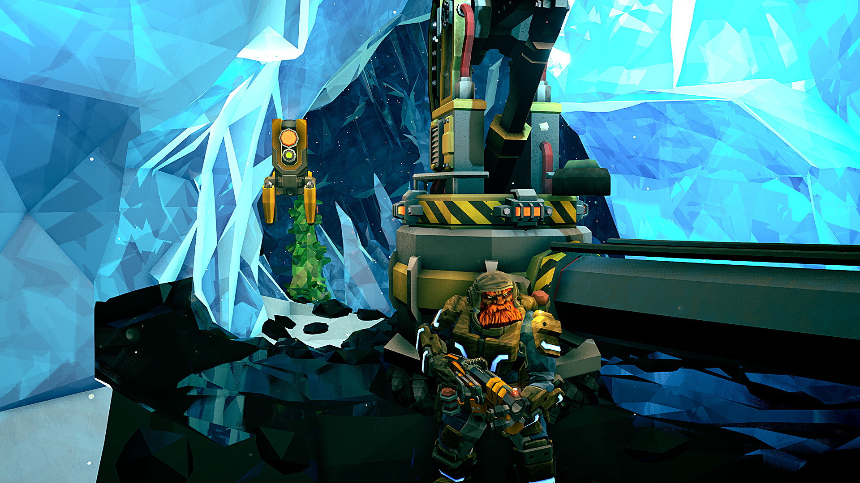

Figure 6.11A Deep Rock Galactic by Ghost Ship Games

This blend of high quality textures mixed with low poly models provides a powerful artstyle combination mixing old with new.

#### 6.11.1 Concept Art

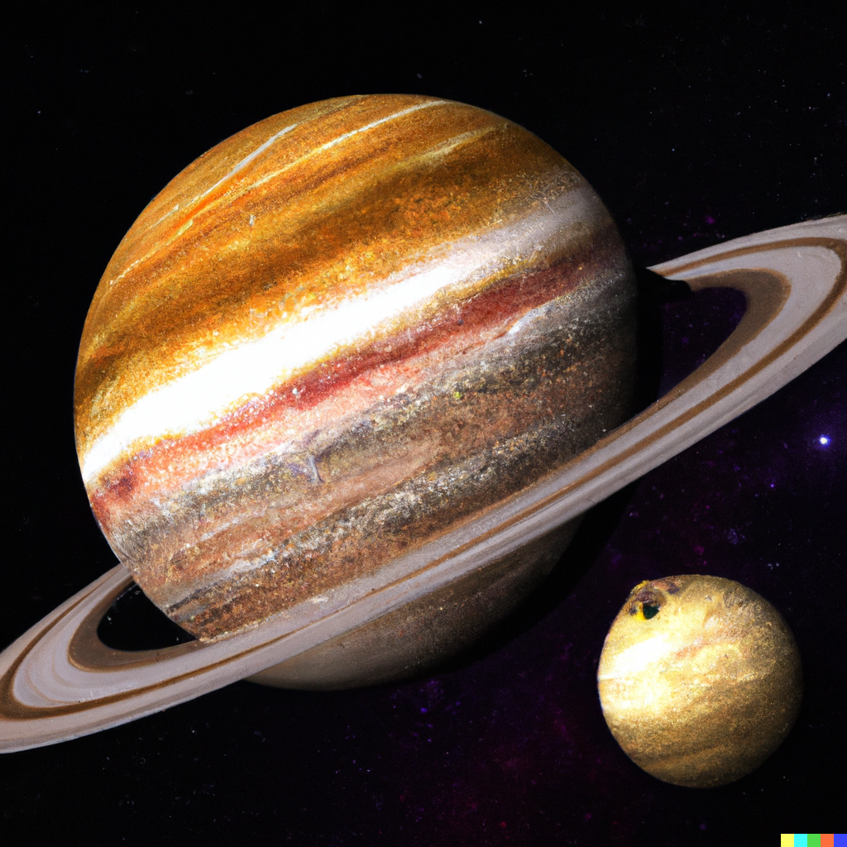

Figure 6.11.1A Gas Giant with asteroid belt the main setting of the game, generated by DALL-E

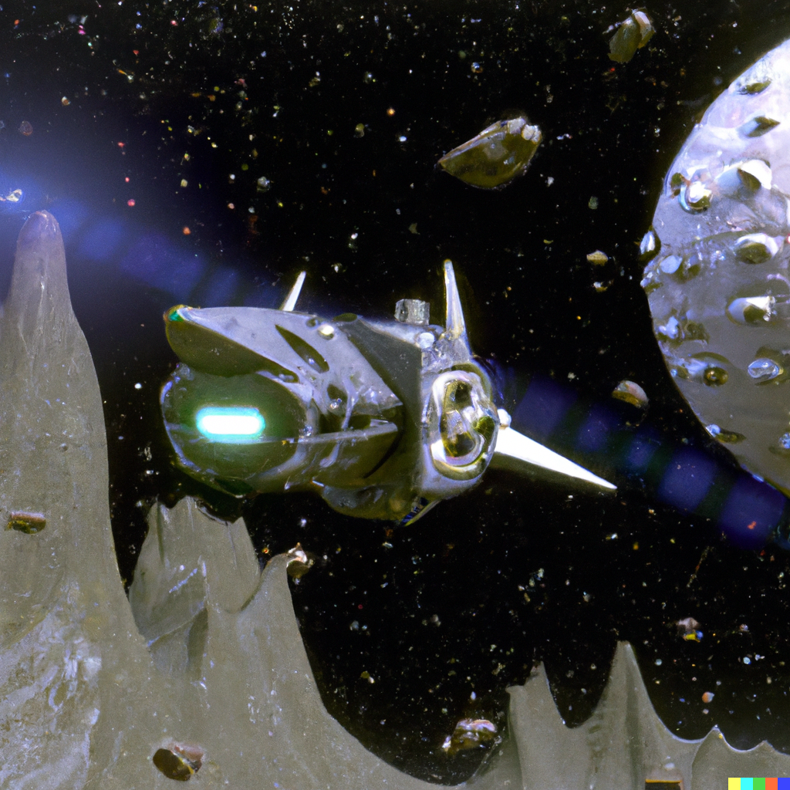

Figure 6.11.1B Player Controlled Ship navigating asteroids generated by DALL-E

## 

Figure 6.11.1C Low Poly Spacecraft generated by DALL-E

## 7. References

Suter, B., Kochler, M. and Bauer R. (2019) ‘’Games and Rules : Game Mechanics for the Magic Circle, transcript Verlag, 2019

Alexander, G., Penny, S. (2020) ‘A Hybrid Approach to Procedural Generation of Roguelike Video Game Levels’, FDG '20: International Conference on the Foundations of Digital Games, September 15–18, 2020

Serpa, Yvens (2020) The Pillars of Internal Economy — An Introduction to Game Economics<https://medium.com/cores-of-game-design/the-pillars-of-internal-economy-an-introduction-to-game-economics-38d8e73d5afa> [Accessed: 10th October 2022]

Ernest, A. and Dormans, J. (2012) Game Mechanics: Advanced Game Design (Voices That Matter), New Riders

Smith, G.S. 2015 Procedural Content Generation: An Overview, Raben, S.R. Game AI Pro 2: Collected Wisdom of Game AI Professionals. A K Peters/CRC Press, 501-517

Tommy Thompson (6/5/20) *Building the AI of F.E.A.R. with Goal Oriented Action Planning*

[*https://www.aiandgames.com/2020/05/06/ai-101-goap-fear/*](https://www.aiandgames.com/2020/05/06/ai-101-goap-fear/)[Accessed: 21st October 2022]

Orkin,J. (2006) Three States and a Plan: The A.I. of F.E.A.R [Accessed: 11th October 2022]

<https://alumni.media.mit.edu/~jorkin/gdc2006_orkin_jeff_fear.pdf>

Takeuchi, H. & Nonaka, I., 1986. The New New Product Development Game. [Online]

Available at: <https://hbr.org/1986/01/the-new-new-product-development-game>

[Accessed 9th November 2022].

Keith,C (2010) Agile Development with Scrum: Teams <https://www.gamedeveloper.com/production/agile-game-development-with-scrum-teams>

[Accessed 15th November 2022]

Pontes, R.G and Gomes, H.M (2020) *‘Evolutionary Procedural Content Generation for an Endless Platform Game’,*Recife, Brazil, 07-10 November 2020, 2020 19th Brazilian Symposium on Computer Games and Digital Entertainment (SBGames), Page(s):80 - 89,<https://ieeexplore.ieee.org/abstract/document/9291659> [Accessed 27th November 2022]

### Image Sources

Fig 4.2A Video Game Market Size estimation [[LINK]](https://www.statista.com/outlook/amo/media/games/worldwide#revenue)

Fig 4.2B Estimated Sales Revenue of Enter the Gungeon [[LINK]](https://games-stats.com/steam/game/enter-the-gungeon/)

Fig 4.2C Player Counts of Enter the Gungeon [[LINK]](https://steamdb.info/app/311690/graphs/)

Fig 4.2D Estimated Sales Revenue of Vampire Survivors [[LINK]](https://games-stats.com/steam/game/vampire-survivors/)

Fig 4.2E Player Counts of Vampire Survivors [[LINK]](https://steamdb.info/app/1794680/graphs/)

Fig 4.2.2A Enter the Gungeon in game screenshot [[LINK]](https://store.steampowered.com/app/311690/Enter_the_Gungeon/)

Fig 4.2.2B Enter the Gungeon in game screenshot [[LINK]](https://store.steampowered.com/app/311690/Enter_the_Gungeon/)

Fig 4.2.2C The Ascent promotional art [[LINK]](https://store.steampowered.com/app/979690/The_Ascent/)

Fig 4.2.2D The Ascent in game screenshot [[LINK]](https://store.steampowered.com/app/979690/The_Ascent/)

Fig 4.2.2E Nuclear Throne Promotional art [[LINK]](https://store.steampowered.com/app/242680/Nuclear_Throne/)

Fig 4.2.2F Nuclear Throne in game screenshot [[LINK]](https://store.steampowered.com/app/242680/Nuclear_Throne/)

Fig 6.11.1 A-C Generated by DALL-E [[LINK]](https://openai.com/dall-e-2/)

## 8. Dev Log Playlist and Pre-Recorded Demo

Dev Log

<https://youtube.com/playlist?list=PLkB4xAXWjY-pyBsY58hzCnh6IvlqR4kV6>

Demo/Final Devlog

<https://youtu.be/pYlWef6Yqwg>